LAB CYCLE – 5

Program 1:

Write a program to determine whether a given year is a leap year [ Use Calendar
Module

Source code:

import calendar
year = int(input("Enter a year to check: "))
if calendar.isleap(year):
print(f"{year} is a leap year")
else:
print(f"{year} is not a leap year")

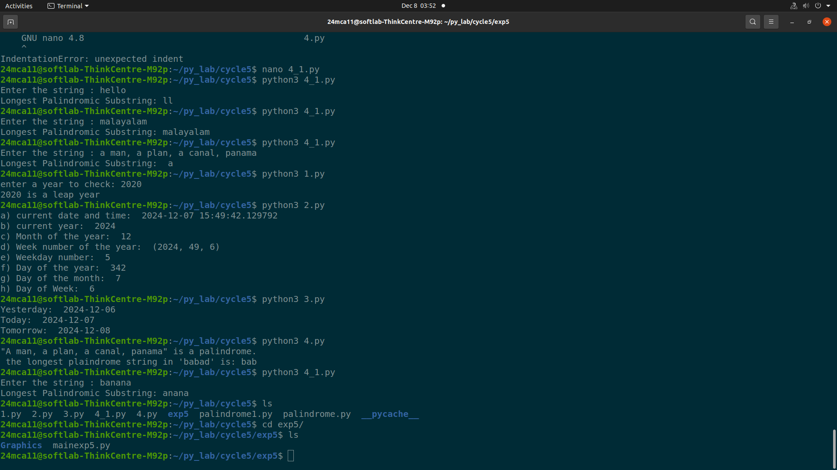
Output:
Program 2:

Write a python script to display
a) Current date and time
b) Current Year
c) Month of the year
d) Week number of the year
e) Weekday of the week
f) Day of year
g) Day of the month
h) Day of week [ Use time and datetime Module]

Source code:

import datetime

now = datetime.datetime.now()

print("a) Current Date and Time:", now)

print("b) Current Year:", now.year)

print("c) Month of the Year:", now.month)

print("d) Week Number of the Year:", now.isocalendar()[1])

print("e) Weekday Number:", now.weekday())

print("f) Day of the Year:", now.timetuple().tm_yday)

print("g) Day of the Month:", now.day)

print("h) Day of Week:", now.isoweekday())

Output:

Program 3:

Write a python program to print yesterday, today and tomorrow.

Source code:

from datetime import date, timedelta

today = date.today()
yesterday = today - timedelta(days=1)
tomorrow = today + timedelta(days=1)

print("Yesterday:", yesterday)
print("Today:", today)
print("Tomorrow:", tomorrow)

Output:

Program 4:

Write a function in file palindrome.py to check whether a string is Palindrome or not.
Import the module to find the longest palindromic substring in a given string by
checking every possible substring and verifying if it is a palindrome

Source Code:

from palindrome1 import is_palindrome

def longest_palindromic_substring(s):

longest = ""
for i in range(len(s)):
for j in range(i + 1, len(s) + 1):
substring = s[i:j]
if is_palindrome(substring) and len(substring) > len(longest):
longest = substring

return longest

input_string = input("Enter the string : ")
print(f"Longest Palindromic Substring: {longest_palindromic_substring(input_string)}")

Output:

Program 5:

Create a package graphics with modules rectangle, circle and sub-package 3D-graphics
with modules cuboid and sphere. Include methods to find area and perimeter of
respective figures in each module. Write programs that find the area and perimeter of
figures by different importing statements. (Include selective import of modules and
import * statements)

Source code:

mainexp5.py
from Graphics import rectangle as r
from Graphics import circle as c
from Graphics.three_d_graphics import cuboid as cb
from Graphics.three_d_graphics import sphere as s

while(True):
fun=int(input("Select any one:\n1.rectangle\n2.circle\n3.cuboid\n4.sphere\n5.exit\n "))
if(fun==1):
l=int(input("\nLength: "))
w=int(input("\nwidth: "))
print("\nArea: ",r.area(l,w))
print("\nPerimeter: ",r.perimeter(l,w))

elif(fun==2):
r=int(input("\nRadius: "))
print("\nArea",c.area(r))

elif(fun==3):
l=int(input("\nLength: "))
w=int(input("\nwidth: "))
h=int(input("\nheight: "))
print("\nArea: ",cb.area(l,w,h))
print("\nPerimeter: ",cb.perimeter(l,w,h))

elif(fun==4):
r=int(input("\nRadius: "))
print("\nArea",s.area(r))
print("\nVolume",s.volume(r))

elif(fun==5):break;
elif(fun not in [1,2,3,4,5]):
print("Invalid choice")

circle.py
import math as m
def area(r):
return m.pi*r*r
def circumference(r):
return 2*m.pi*r

rectangle.py
def area(l,w):
return l*w
def perimeter(l,w):
return 2*(l+w)

cuboid.py
def area(l,w,h):
return 2*(l*w + w*h + l*h)
def perimeter(l,w,h):
return 4*(l+w+h)

sphere.py
import math as m
def area(r):
return 4*m.pi*r*r
def volume(r):
return 4/3*m.pi*r*r*r

Output:

